5.1.1 Leap Year Checker
Aim: Write a Python program that prompts the user to enter a year. The program should determine if the year is a leap year or not and print the appropriate message.

Algorithm
Step 1:Start.
Step 2:Read the year from the user
Step 3:If the year is divisible by 400 → Print "Leap Year”
Step 4:Else if the year is divisible by 100 → Print "Not a Leap Year”
Step 5:Else if the year is divisible by 4 → Print "Leap Year”
Step 6:Else → Print "Not a Leap Year” Step 7:Stop
FLOWCHART

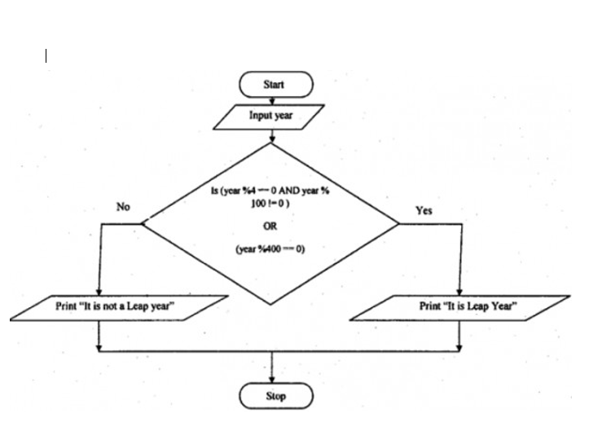

EXECUTION
